INSERT YOUR LOCAL HEALTH BOARD LOGOHERE

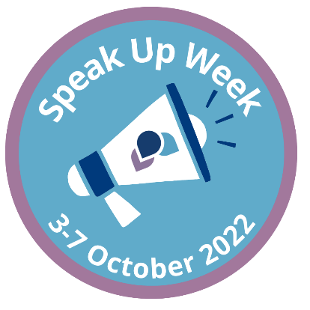

**Want to speak up, but don't know who to turn to?**

Find out more about Speak Up Week using the QR code below:

INSERT QR CODE FOR YOUR INTRANET PAGE FOR SPEAK UP WEEK (OR DELETE)

**Your local confidential contact is:**

INSERT CONFIDENTIAL CONTACT DETAILS HERE

