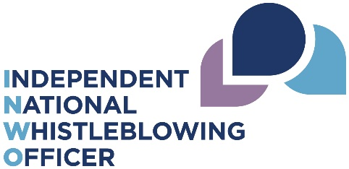
National Whistleblowing Standards
Key Performance Indicator checklist
Minimum information required for annual reports to meet reporting requirements on KPIs. This can be modified to include other local requirements, but must be reported distinctly from the whistleblowing KPI data.
KPI | Requirement
1 | a statement outlining learning, changes or improvements to services or procedures as a result of consideration of whistleblowing concerns
2 | a statement to report the experiences of all those involved in the whistleblowing procedure (where this can be provided without compromising confidentiality)
3 | a statement to report on levels of staff perceptions, awareness and training
4 | the total number of concerns received
5 | concerns closed at stage 1 and stage 2 of the whistleblowing procedure as a percentage of all concerns closed
6 | concerns upheld, partially upheld, and not upheld at each stage of the whistleblowing procedure as a percentage of all concerns closed in full at each stage
7 | the average time in working days for a full response to concerns at each stage of the whistleblowing procedure
8 | the number and percentage of concerns at each stage which were closed in full within the set timescales of 5 and 20 working days
9 | the number of concerns at stage 1 where an extension was authorised as a percentage of all concerns at stage 1
10 | the number of concerns at stage 2 where an extension was authorised as a percentage of all concerns at stage 2

